**Part 1**

**Description of System**

The system I will be analysing is a GPS navigation system aimed at helping users reach their destinations. It is integrated into the vehicle and primarily controlled via the touchscreen on the dashboard and for accessibility, voice commands are supported for all functions. To use it, users start the car, initiating the GPS, and input their destination either manually or verbally. Multiple route options are calculated and displayed, allowing users to choose based on preferences like distance, time, or weather conditions. During navigation, the map displays the user's location, with audible directions provided. Alerts for emergencies and warnings are displayed via the screen, voice prompts, and subtle vibrations in the seat depending on the severity.

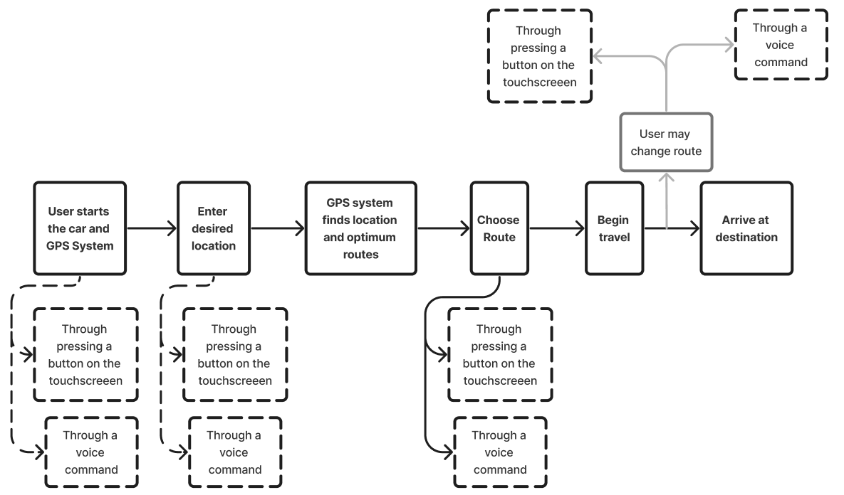*User Journey Diagram*

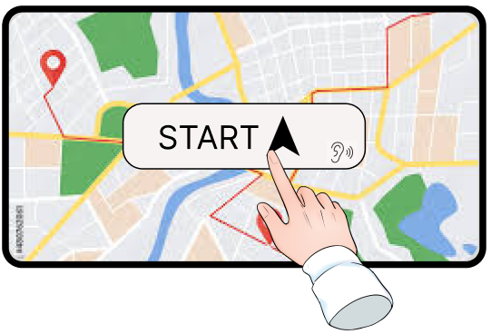

*Start GPS via Touchscreen*

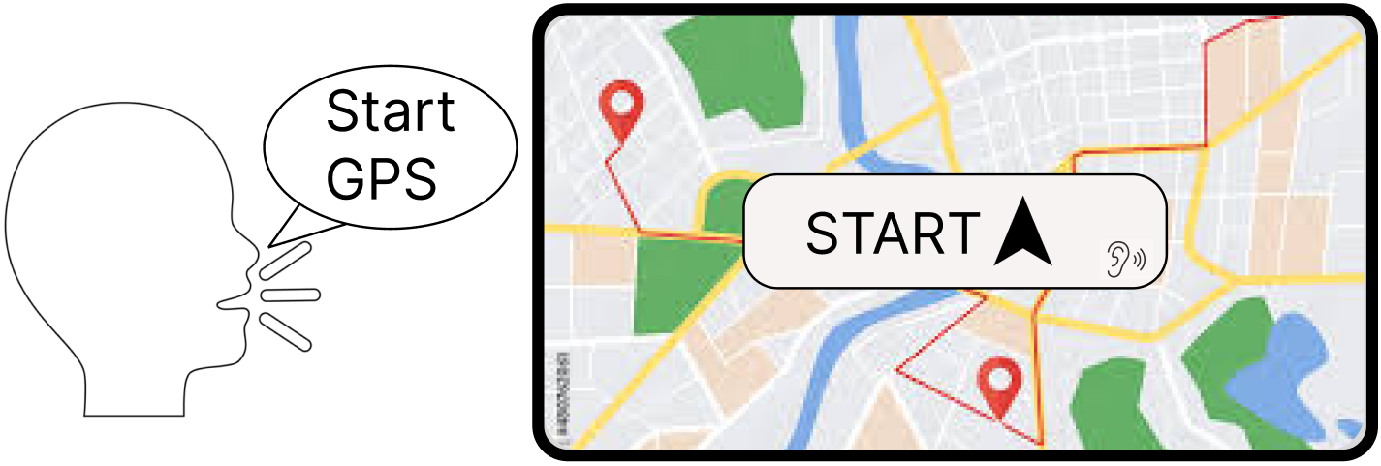

*Start GPS via Voice Command*

 *Alert on Touchscreen*

**Methods of Interaction *Examples***

|  |  |  |  |
| --- | --- | --- | --- |
| **Visual** | *Looking at Map* | *Looking at Images* | *Reading Directions* |
| **Auditory** | *Saying Commands* | *Listening to Directions* | *Listening to Alerts* |
| **Touch/Physical** | *Entering Destination* | *Choosing Route* | *Changing Settings* |
| **Haptic** | *Vibrations from Alerts* |  |  |

**Part 2**

**Distributed Cognition (DC) Analysis**

Distributed cognition (DC) widens the lens of cognition from occurring only within the head to being socially, materially, and temporally distributed within a dynamic system (Boyle, J. G. *et al.* (2023)). This is especially relevant for analysing GPS systems where the activity of driving is heavily reliant on the GPS system, meaning users and other drivers' safety is a major concern.

**Unit of analysis**

The DC analysis starts with defining the Unit of Analysis which refers to the components involved in any of the tasks performed in the system to achieve computation and is comprised of the following:

* Driver
* Car
* GPS System: Touchscreen display, Map and Weather database, Alert System, etc.
* Passengers
* Other people/Strangers/Locals
* Desired Location

**Memory representations**

The second stage of the DC analysis is identifying the internal and external memory representations which show where the information required to perform the task is stored (Hollan et al., 2000).

**Internal representations**

* Destination to travel to – they must have at least a vague idea of the name of the desired location to enter the system.
* An idea of what the area looks like if the user uses the images to form an idea of the desired location.
* The directions given by the system and how to follow/perform them.
* Voice commands recognised and given by the GPS system.
* When and how to display the appropriate warning through the multiple modes – through the touchscreen or voice commands by the system.

**External representations**

* The destination to travel to and directions to take displayed via the touchscreen and through voice commands by the system.
* The possible routes to take and which account for the user preferences such as traffic.
* The display the appropriate warning through the multiple modes – through the touchscreen or voice commands by the system.

**Information Channels**

The third stage of the DC analysis is finding the information channels which is the information passed between memory representations and its direction flow.

1. Sending of Data from the databases/APIs. These may include the weather, locations, current traffic.
2. Conversations between people in the system. These may include discussions of what route/directions to take etc.
3. Commands/Information provided to the GPS system. These may include destinations to travel to, which routes to take etc.
4. Commands/Information provided by the GPS system. These may include which directions to take, confirmation of user provided commands etc.
5. Communication between the Touchscreen and Alert system. This may be done to send the alert to display on the touchscreen.

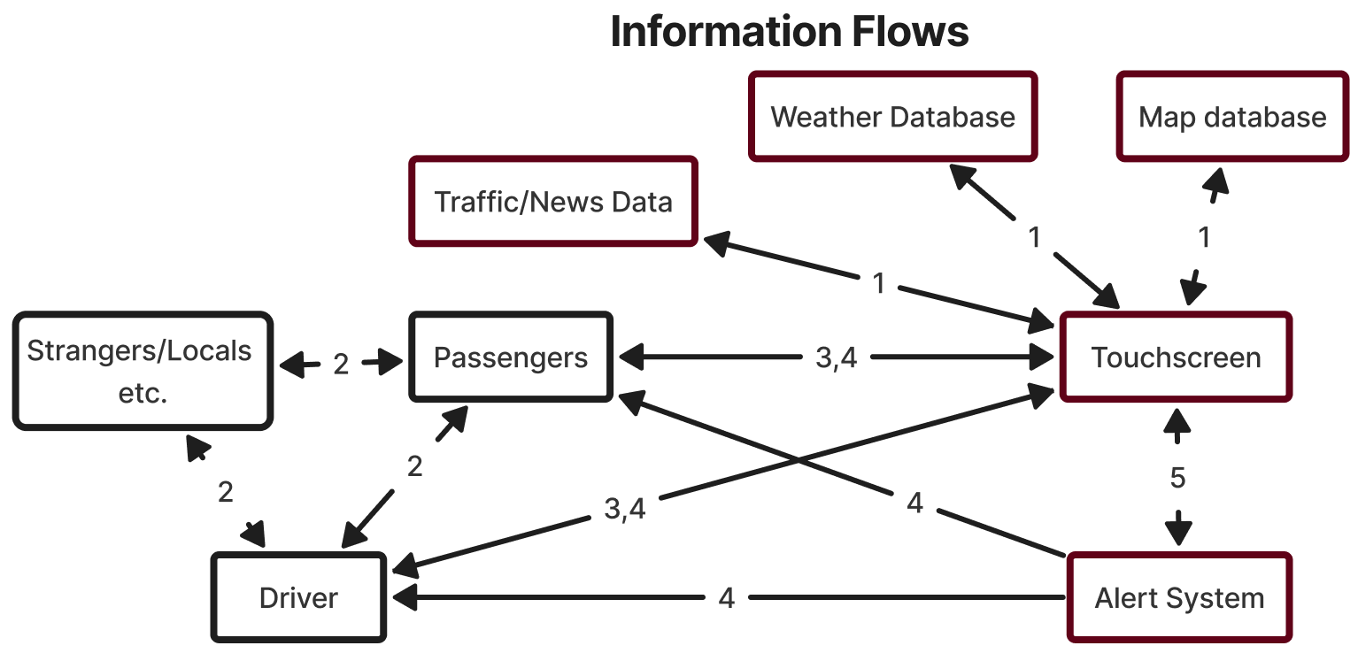*Note: The boxes in Red encompass the GPS System*

**Computation and Processing**

The final stage of the DC analysis is identifying the computation and processing needed to achieve the task.

**Internal**

* User must compute whether the journey is possible. They must consider fuel, car quality, legality etc.
* The user must make the decision of what route to take, the preferences in weather and distance etc. and the effect on the journey.
* The user needs to know how to interpret the commands provided by the GPS system.

**External**

* Using the GPS system to compute whether the journey is possible.
* The GPS system must make calculations for finding the destination, a suitable route and consider the preferences set by the user.
* If the route has been altered, the GPS system must account for this.
* If the driver makes a mistake with the direction, a new route must be computed to set them on the correct path.
* Based on the type of alert, the system must accurately display and convey to the user. If the alert requires haptic feedback, then that is what is used.
* Consider traffic, driving conditions and weather based on current news.
* System must accurately process the commands given by the user.

**Insights from DC Analysis**

The system efficiently provides essential journey information, including routes, weather conditions, and alerts for potential hazards, significantly reducing cognitive load for users. This allows them to focus more on driving without the need to consult signs or paper maps. The information flow diagram illustrates that the primary interaction occurs between users and the GPS system, with occasional external interactions, such as the system accessing weather data. By functioning in tandem with drivers, akin to a co-pilot offering directions and monitoring conditions, the system shares cognitive tasks effectively. For instance, users handle inputting destinations and commands during the start of the journey, while voice commands ease the process during driving such as changing locations, shifting computational burdens to the system. This collaborative approach optimises cognitive load management, balancing internal and external processing between users and the GPS system.

The current system faces a problem as users are required to learn and remember specific commands to verbally interact with the system. This presents a usability issue, as users may struggle to recall the exact phrases needed to execute commands. To address this, an AI-based solution can streamline command processing by interpreting general commands from users and translating them into system recognisable commands, enhancing usability and reducing the learning curve for users.

Areas of uncertainty in my analysis were in my unit of analysis as I consider the GPS system to be its own entity and provide examples of the elements that it consists of such as the touchscreen. This was done to reduce the convolution, but it may be preferable to consider these elements separately as part of the unit of analysis. Additionally, broadening the unit of analysis to include individual components like the touchscreen interface and navigation algorithms could provide deeper insights into the system's functionality. Moreover, integrating artefacts and social considerations can enrich the analysis by providing valuable insights into user interactions and system performance.

**Part 3**

AT views human activity in terms of a system of tool-mediated actions carried out by a subject such as an individual or a group of individuals for the result of achieving a desired outcome (Metatla et al., (2014)) 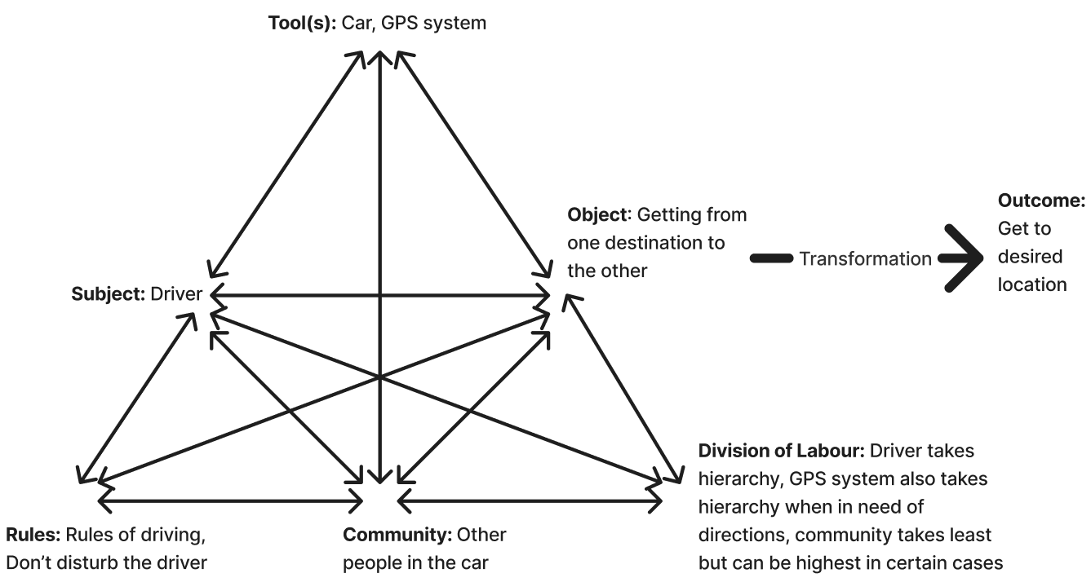

**Activity Theory VS Distributed Cognition**

AT focuses on the singular activity of driving with a GPS system, examining how the driver's actions transform this activity. This narrow focus allows for a detailed representation of the system and activity. However, DC analysis considers multiple activities within the broader cognitive system. While this broader scope can capture the complexity of the activity, it may overlook certain nuances present in the driving task such as changing gears or looking at different mirrors.

AT incorporates social considerations into its analysis, including potential negative stereotypes associated with using GPS systems. This aspect adds depth to the understanding of the activity and its socio-cultural context. On the other hand, DC does not explicitly address the social aspects of the activity, which may result in a less comprehensive analysis in this regard.

Furthermore, AT emphasizes the historical context of artifact use, which can influence the interpretation of the activity. This historical perspective is not explicitly considered in DC analysis, potentially affecting the depth of the analysis.

In the context of DC, both human and non-human agents are given equal consideration whereas AT uniquely focuses on dissecting human activity as the crucial point of analysis (Baumer, Eric & Tomlinson, Bill. 2011). This approach is particularly relevant in systems where the human driver plays a crucial role, guiding all actions. Understanding the social context of the driver becomes pivotal in enhancing system design. For instance, AI could be employed to gain insights into the driver's behavior and preferences, thereby improving future journeys without requiring direct user input.

**References**

Boyle, J. G. *et al.* (2023) ‘Distributed cognition: Theoretical insights and practical applications to health professions education: AMEE Guide No. 159’, *Medical Teacher*, 45(12), pp. 1323–1333. doi: 10.1080/0142159X.2023.2190479.

Hollan, J., Hutchins, E., & Kirsh, D. (2000). Distributed Cognition: Toward a New Foundation for Human-Computer Interaction Research.

Metatla, O., Martin, F., Stockman, T., & Bryan-Kinns, N. (2014) Developing Methods and Techniques for the Design of Cross-modal Interfaces. Page 1.

Baumer, Eric & Tomlinson, Bill. (2011). Comparing activity theory with distributed cognition for video analysis: Beyond "kicking the tires". 133-142. 10.1145/1978942.1978962.